World’s Ant Forum Bangkok, 2019 and the 12th ANeT Meeting 11- 15 Nov
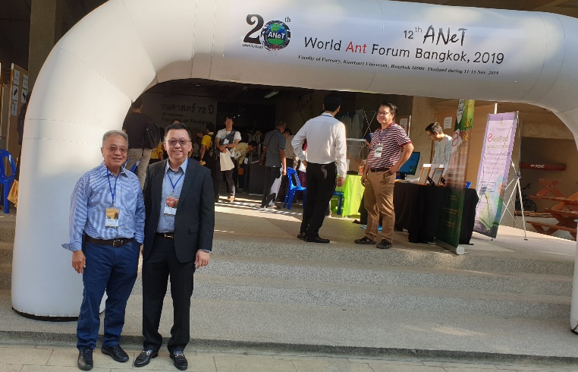

Registration at the main entrance of the Faculty of Forestry, The KasetSart University

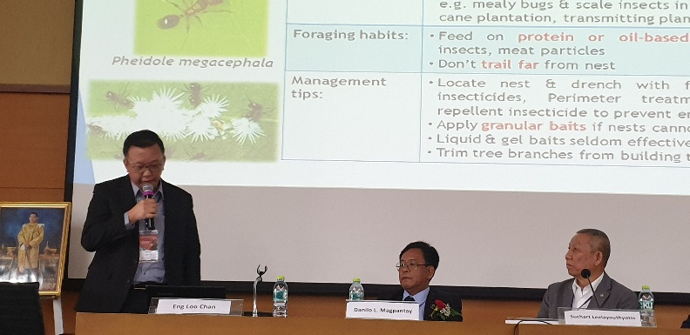

Mr Andrew Chan presenting his talk on ‘Pest Ant Management in Singapore’ during the Forum

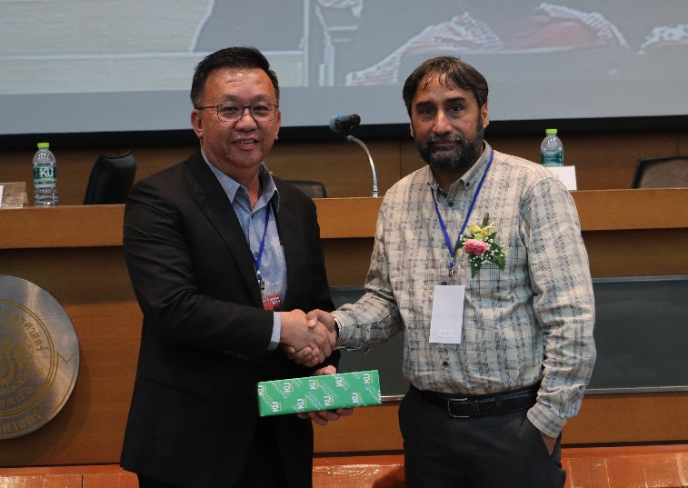

Dr. Himender Bharti President of ANeT. India presenting the momento to Mr Andrew Chan.

The World’ Ant Forum was held at The KasetSart University, Faculty of Forestry, Thailand. Both the President and Vice President of SPMA were invited by the Thailand Pest Management Association (TPMA) to attend the Forum.
The venue of the Forum, The KasetSart University, Faculty of Forestry is of strong historical heritage. It was found on 1st May 1936 and is the first and only academic institution in Thailand offering higher education in forestry and wildlife resources for Bachelor, Master and Doctor of Philosophy degrees. It also runs the largest Rama 9 Ecological Museum in Southeast Asia.
The Forum gathered some of the renowned ant researchers to present their latest research findings and innovations. For the first time, pest management specialists and pesticide product suppliers were also invited. Together with the Presidents of the Pest Management Associations of Thailand and Malaysia, Mr Andrew Chan the President of SPMA made a short presentation on ‘Pest Ant Management in Singapore’.
The five day’s event covered presentations by the various ant researchers on topics including ant taxonomy; biology & ecology; behavior and management. There was also an exhibition showcasing the latest ant management products and innovations; edible ants innovation; keeping ants as pet as well as ants in Thailand; Participants were also offered an opportunity to visit Rama 9 Ecological Museum. A short training course on ants was also included in the programme with site visits to observe and study the forest ants behavior and their relatioships with the forest ecosystem.

